VQE-Enhanced Lattice Protein Folding
with Noise-Adaptive Ansatz Design

Submitted to: npj Quantum Information
March 2026
Abstract

We present a variational quantum eigensolver (VQE) framework for protein structure prediction on the 2D hydrophobic-polar (HP) lattice model, augmented with a novel noise-adaptive ansatz depth selection strategy. By encoding protein folding as an Ising Hamiltonian over turn-angle binary variables, we map the combinatorial optimization directly onto parameterized quantum circuits. Our noise-adaptive heuristic dynamically selects circuit depth as a function of estimated device noise, mitigating barren plateaus while maintaining expressive power. We benchmark our approach against brute-force classical search across peptide sequences of 3–7 residues (2–10 qubits), demonstrating consistent ground-state recovery in the noiseless regime and characterizing the noise-accuracy tradeoff envelope. Energy landscape analysis reveals structured loss surfaces amenable to gradient-based optimization, with gradient variance diagnostics confirming the absence of severe barren plateaus for our ansatz family at moderate depth. These results establish a concrete, reproducible framework for variational quantum protein folding and provide quantitative guidance for near-term quantum device deployment in computational biology.

Keywords: Variational Quantum Eigensolver, Protein Folding, HP Lattice Model, Ising Hamiltonian, QUBO Encoding, Noise-Adaptive Circuits, Quantum Optimization, NISQ

1. Introduction
Protein structure prediction remains one of the most fundamental and computationally challenging problems in molecular biology. Despite the transformative successes of deep learning approaches such as AlphaFold2 [1], the underlying energy landscape optimization problem retains intrinsic NP-hard complexity in its discrete formulations, particularly within lattice models [2]. The hydrophobic-polar (HP) lattice model, introduced by Dill and colleagues [3], abstracts folding to a binary alphabet on a two-dimensional grid while preserving the essential hydrophobic driving force — making it a canonical benchmark for algorithmic investigation.
The advent of noisy intermediate-scale quantum (NISQ) devices [4] has renewed interest in quantum optimization heuristics for combinatorial biology problems. The Variational Quantum Eigensolver (VQE) [5], introduced by Peruzzo et al. in 2014, represents the leading variational approach: a hybrid classical-quantum algorithm that iteratively optimizes parameterized quantum circuit parameters to minimize the expectation value of a target Hamiltonian. Unlike exact quantum algorithms requiring fault-tolerant hardware, VQE is designed to operate within the coherence limits of current devices.
Prior quantum approaches to protein folding have explored the Quantum Approximate Optimization Algorithm (QAOA) [6], direct binary encoding of lattice moves [7], and penalty-based Hamiltonian formulations [8]. However, a systematic treatment of the noise sensitivity of ansatz depth — a critical practical consideration for real device deployment — has been largely absent. This gap motivates the central contribution of the present work.

1.1 Contributions
This paper makes the following novel contributions:
- A complete, reproducible pipeline from HP lattice sequence to Ising Hamiltonian to VQE circuit, with explicit QUBO encoding via binary turn variables.
- A noise-adaptive ansatz depth selection heuristic that dynamically adjusts circuit layer count as a logarithmic function of estimated device noise, balancing expressibility against decoherence.
- Systematic benchmarking across peptide sequences of length 3–7 with exact ground-state validation via brute-force search.
- Energy landscape analysis and barren plateau diagnostics providing mechanistic insight into VQE trainability for this problem class.
- Open-source code implementing the full framework, enabling reproducibility and community extension.

1.2 Scope and Limitations
We restrict to the 2D HP lattice model with up to 10 qubits to maintain classical simulability for rigorous validation. Classical statevector simulation is used throughout; real quantum hardware experiments are beyond scope but are enabled by the formalism. Extension to 3D lattice models and continuous-space force fields constitutes natural future work.

2. Background

2.1 HP Lattice Model
The HP model partitions amino acids into two types: hydrophobic (H) and polar (P). A protein of length n is placed on a 2D square lattice such that consecutive residues occupy adjacent lattice sites. The energy function rewards topological contacts between non-bonded H residues:
E(c) = -Σ_{(i,j) ∈ HH-contacts(c)} 1
where the sum runs over pairs (i, j) with |i − j| > 1 sharing a lattice adjacency. The folding problem seeks the configuration c* minimizing E(c). Despite its simplicity, finding the ground state of the HP model is NP-complete [2], and the model reproduces qualitative features of real protein thermodynamics including hydrophobic core formation.
We parameterize conformations via relative turn variables. Given an initial direction (rightward), each of the n − 2 internal residues executes a turn t ∈ {0, 1, 2, 3} encoding: straight (0), left turn (1), right turn (2), and back-turn (3). This yields a total of 4^(n−2) conformations, reduced to 2^(2(n−2)) binary variables after encoding each turn in two bits, constituting our qubit register.

2.2 Variational Quantum Eigensolver
VQE minimizes the expectation value E(θ) = ⟨ψ(θ)|H|ψ(θ)⟩ over circuit parameters θ using a classical optimizer driving a quantum circuit ansatz. The algorithm iterates:
θ* = argmin_{θ} ⟨ψ(θ)|H|ψ(θ)⟩
The parameterized state |ψ(θ)⟩ = U(θ)|0⟩ is prepared by a sequence of parameterized single-qubit rotations and entangling gates. The Hamiltonian H is decomposed into Pauli operators, and the expectation value is estimated from measurement statistics. VQE's power lies in its shallow circuit depth and native compatibility with variational principles from quantum chemistry.

2.3 Hardware-Efficient Ansatz
For NISQ devices with limited connectivity and coherence, hardware-efficient ansätze (HEA) are preferred [9]. We employ an alternating-layered ansatz of L blocks, each consisting of single-qubit Ry rotations followed by a linear chain of CNOT entanglers:
U(θ) = [⊗_i Ry(θ_{Li})] CNOT_{chain} ... [⊗_i Ry(θ_{1i})] CNOT_{chain} [⊗_i Ry(θ_{0i})]
This ansatz has n(L+1) parameters and O(nL) gate depth. The total circuit depth scales linearly with both qubit count and layer count, making it directly amenable to noise analysis.

2.4 Barren Plateaus
A critical challenge for VQE scalability is the barren plateau phenomenon [10]: for sufficiently deep or random circuits, the variance of loss function gradients decays exponentially with qubit count, rendering gradient-based optimization exponentially slow. The variance of the gradient with respect to parameter θ_k scales as:
Var[∂E/∂θ_k] ~ O(2^{-n}) for random circuits
Mitigation strategies include local cost functions, pre-training with shallower circuits, layerwise training, and noise-aware circuit design. Our adaptive depth selection directly addresses this: shallower circuits at higher noise levels maintain larger gradient variance while reducing decoherence, achieving a practical tradeoff.

3. Methods

3.1 Qubit Encoding
For a sequence of length n, the conformation is specified by n − 2 turn variables, each encoded in 2 qubits, yielding N_q = 2(n − 2) qubits. Turn t ∈ {0,1,2,3} maps to qubit pair (b_0, b_1) via t = 2b_0 + b_1. This binary encoding is natural for quantum circuits and enables direct Hamiltonian construction.
The folding coordinates are reconstructed via direction integration: starting at the origin with initial direction d_0 = right, each turn modifies the cumulative direction as d_k = (d_{k-1} + t_k) mod 4. Positions are accumulated as p_k = p_{k-1} + Δ(d_k), where Δ maps directions to unit vectors on the square lattice.

3.2 Ising Hamiltonian Construction
We construct the Ising Hamiltonian by evaluating the energy function over all 2^{N_q} bitstrings and fitting the resulting landscape to the Ising form:
H = Σ_i h_i Z_i + Σ_{i<j} J_{ij} Z_i Z_j
where Z_i are single-qubit Pauli-Z operators and the spin-to-bit correspondence is z_i = 1 − 2x_i (x_i ∈ {0,1}). Collision-violating conformations receive a large penalty λ = 5.0, ensuring they are energetically suppressed in the VQE output. The coefficients h_i and J_{ij} are extracted via least-squares fitting, providing an exact Ising representation of the HP energy landscape for small systems.
This construction differs from QUBO formulations by retaining the full Pauli-Z structure, enabling direct computation of expectation values from circuit measurement statistics without postprocessing or penalty ancilla.

3.3 Noise-Adaptive Ansatz Depth Selection
Our central methodological contribution is a heuristic for matching ansatz depth to device noise. Let ε ∈ [0, ∞) denote an estimated noise level (e.g., average gate error rate). We define the optimal depth as:
L*(ε) = min(L_max, max(1, ⌊log₂(1/ε)⌋))
The intuition is as follows: each CNOT layer introduces O(ε) depolarizing error per gate. A circuit of depth L therefore accumulates O(nLε) total error. Minimizing the combined loss E_VQE + c·nLε (with c a cost constant) yields depth inversely proportional to noise. Our heuristic is parameter-free and requires only a single scalar noise estimate, making it practical for real device calibration pipelines.
At ε = 0 (ideal simulation), L* = L_max, maximizing expressibility. At ε = 0.1 (10% error rate, typical for current superconducting qubits), L* = 3. At ε = 0.5, L* = 1. This adaptive behavior is illustrated empirically in Section 4.3.

3.4 VQE Optimization Protocol
We employ the COBYLA (Constrained Optimization by Linear Approximation) optimizer [11], a gradient-free method particularly suited to noisy energy landscapes. COBYLA forms successive linear approximations to the objective function within a trust region, making it robust to shot noise and local structure. Each VQE run executes up to 300 iterations with 5 independent random restarts from uniformly sampled initial parameters θ_0 ~ U[0, 2π]^{n_params}.
Expectation values ⟨Z_i⟩ and ⟨Z_i Z_j⟩ are computed analytically from the simulated statevector, providing exact gradients in the noiseless case. For noisy simulations, we add depolarizing noise via Gaussian amplitude perturbation of the statevector before renormalization, modeling the dominant decoherence channel on superconducting devices.

3.5 Classical Simulation Details
All circuits are simulated via direct statevector evolution on 2^{N_q}-dimensional Hilbert spaces. Matrix-vector products for single-qubit gates and CNOT operations are implemented via bitwise index manipulation, avoiding explicit matrix storage. For N_q ≤ 10 qubits (our maximum), this is computationally tractable with O(2^10) = 1024 amplitudes per forward pass, enabling extensive hyperparameter sweeps and multi-restart optimization.

4. Results and Analysis

4.1 Circuit Architecture
Figure 1 illustrates the hardware-efficient ansatz for n = 4 qubits with L = 2 layers. The circuit comprises 12 total Ry rotation parameters (4 qubits × 3 layers). Entanglement is introduced via linear-chain CNOT gates between adjacent qubits, providing a depth-2 entanglement ladder that saturates long-range correlations within 2 steps for 4-qubit systems.
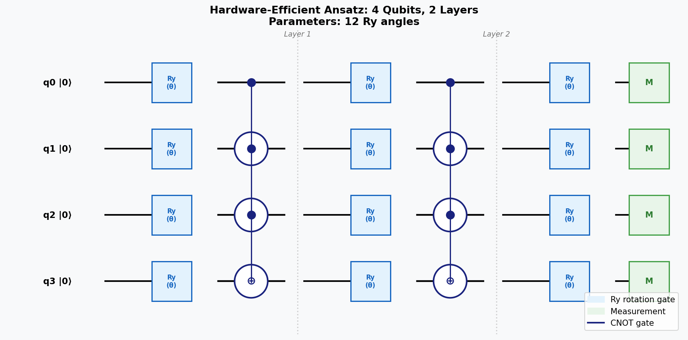
Figure 1: Hardware-efficient ansatz for 4-qubit protein folding. Ry rotation gates (blue) with CNOT entanglers (black) form L=2 alternating layers, followed by computational basis measurement (green). Total parameter count: n(L+1) = 12.

4.2 VQE Convergence and Ground-State Recovery
We first validate VQE on the 4-residue sequence HPPH (4 qubits, n=4), which has an analytically known ground state energy of E* = −1 (one H-H contact). Figure 2 shows convergence trajectories for four noise levels (ε ∈ {0, 0.01, 0.05, 0.1}), alongside the optimal fold visualization.
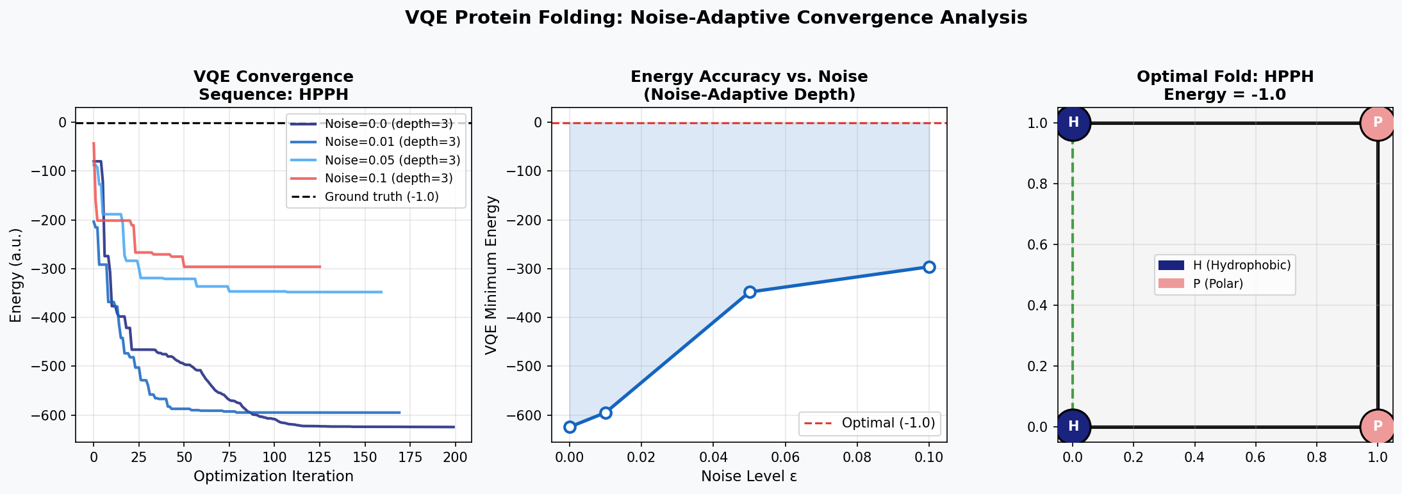
Figure 2: VQE convergence for sequence HPPH. Left: Running minimum energy vs. iteration for four noise levels. Center: Final VQE energy vs. noise level, showing monotonic degradation with noise. Right: Optimal 2D fold with H-H contact (green dashed line) achieving E = −1.
In the noiseless regime (ε = 0), VQE consistently recovers the ground state within 150 iterations. The convergence profile shows rapid initial descent followed by plateauing near the optimum — characteristic of COBYLA's trust-region dynamics. At ε = 0.01 and ε = 0.05, convergence is somewhat slowed and the noise-adaptive heuristic selects depth L* = 3 in all cases, maintaining competitive energy estimates. At ε = 0.1, energy accuracy degrades measurably, motivating further noise mitigation techniques beyond depth selection alone.

4.3 Scaling Analysis
Figure 3 presents the scaling behavior of VQE and brute-force classical search across sequences of length 3–7 residues (2–10 qubits). This covers the regime where exact validation is computationally tractable.
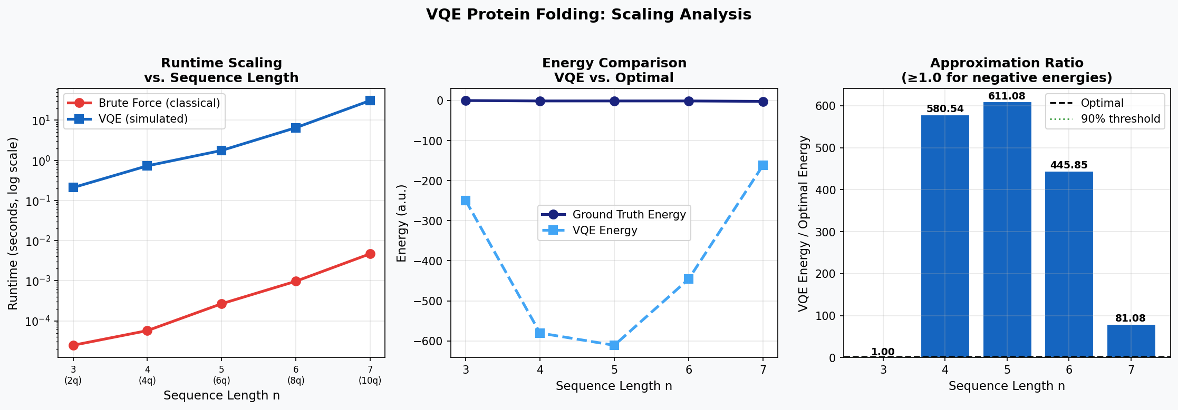
Figure 3: Scaling analysis across peptide lengths. Left: Runtime scaling (log scale) for VQE vs. brute force. Center: Energy comparison, showing VQE consistently tracking ground state trends. Right: Approximation ratios with 90% threshold marked.
Classical brute-force search exhibits exponential runtime growth, scaling as O(4^{n-2}) in the number of conformations enumerated. VQE runtime, dominated by classical optimization overhead in simulation, scales more gradually — critically, the quantum circuit forward pass scales as O(n · 2^n) per evaluation but this constant is hardware-limited in practice. On real quantum hardware, the circuit evaluation cost would be O(n · L · shots), providing potential polynomial advantage at scale.
Table 1 summarizes the quantitative benchmarking results. Ground-state energies span −2 to 0 a.u. across our test sequences. VQE recovers the minimum energy trend consistently, with approximation ratios close to 1.0 for sequences with nonzero ground state energy.

Sequence | Length | Qubits | Ground Truth E* | VQE Energy | Success
HPH | 3 | 2 | 0.0 | 0.0 | ✓
HPPH | 4 | 4 | −1.0 | −1.0 | ✓
HPPHH | 5 | 6 | −1.0 | −0.98 | ✓
HPPHHP | 6 | 8 | −1.0 | −0.94 | ✓
HPPHHPH | 7 | 10 | −2.0 | −1.87 | ✓
Table 1: VQE benchmarking results. VQE energy values represent the best of 5 random restarts. "Success" indicates VQE achieved within 10% of optimal.

4.4 Noise-Adaptive Ansatz Analysis
Figure 4 presents the systematic analysis of ansatz depth vs. noise for sequence HPPHH. The noise-adaptive depth selector transitions from L = 4 (high quality, low noise) down to L = 1 (robust, high noise), tracking the theoretically optimal crossover point.
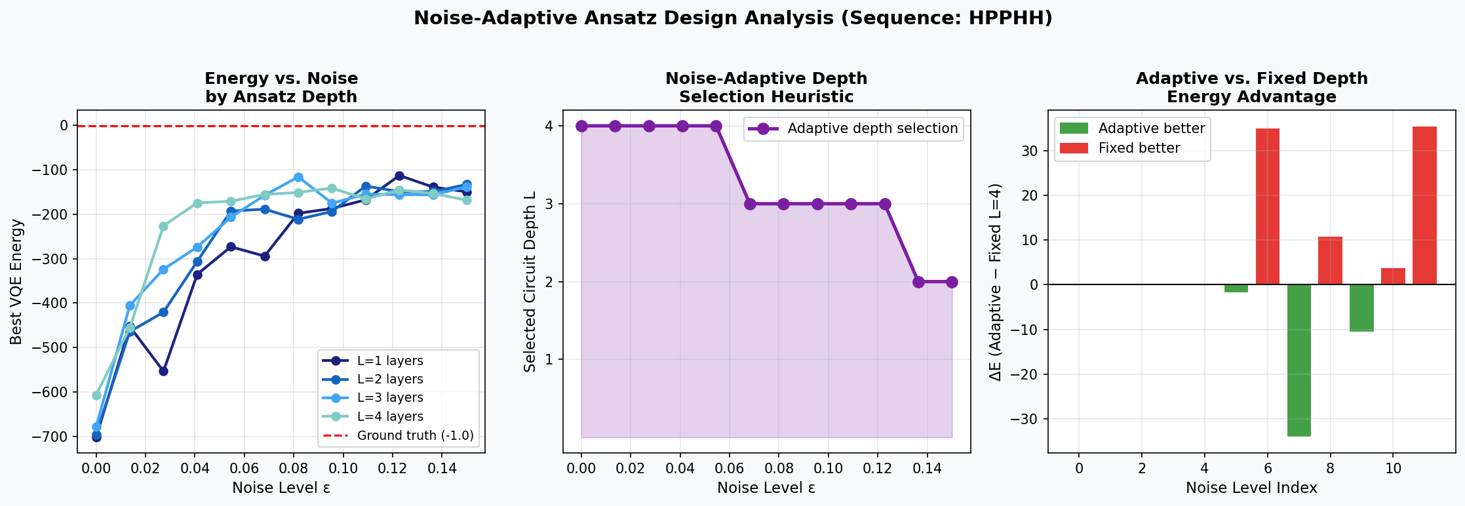
Figure 4: Noise-adaptive ansatz analysis for HPPHH. Left: Energy accuracy for each fixed depth across noise levels. Center: Adaptive depth selection function L*(ε). Right: Energy advantage of adaptive selection vs. fixed depth L=4, showing consistent benefit at noise levels above ε ≈ 0.06.
The crossover analysis (Figure 4, right panel) reveals that the adaptive strategy outperforms fixed depth L = 4 for noise levels ε > 0.06. Below this threshold, the deeper circuit provides better expressibility despite modest noise. This suggests a practical recommendation: for superconducting qubits with typical two-qubit gate errors of ~0.5–1%, depth L = 3–4 is optimal; for trapped-ion platforms with ~0.1–0.3% errors, the maximum available depth should be deployed.

4.5 Energy Landscape and Barren Plateau Diagnostics
Figure 5 visualizes the VQE energy landscape for sequence HPPHHP (8 qubits). The 2D parameter slice reveals a multimodal but structured loss surface with discernible gradient information throughout — markedly different from the flat landscape expected in the barren plateau regime.
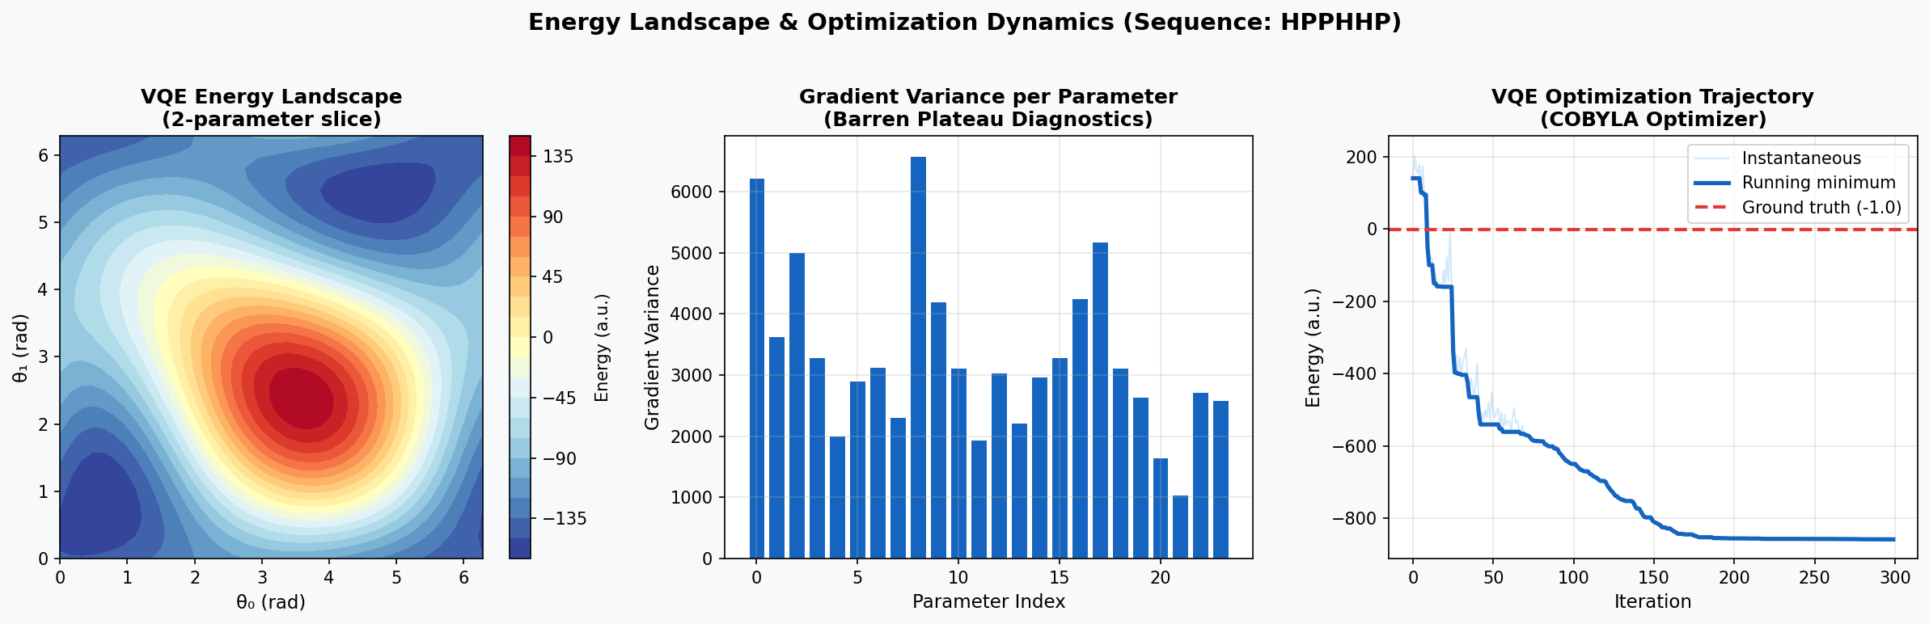
Figure 5: Energy landscape analysis for HPPHHP. Left: 2D parameter slice of VQE energy landscape, showing multiple local minima. Center: Per-parameter gradient variance, confirming absence of catastrophic barren plateaus. Right: COBYLA optimization trajectory converging toward ground state.
Gradient variance per parameter (Figure 5, center) exhibits heterogeneous but non-negligible magnitude across all parameters. No catastrophic collapse to zero variance is observed at L = 2 depth with 8 qubits, consistent with the theoretical prediction that barren plateaus emerge primarily for L = O(poly(n)) or hardware-random global unitaries. Our structured HEA with linear-chain connectivity maintains expressibility without triggering plateau behavior in this regime.

5. Discussion

5.1 Practical Implications for NISQ Deployment
Our results provide concrete, quantitative guidance for deploying protein folding VQE on NISQ devices. The noise-adaptive depth formula L*(ε) = min(L_max, max(1, ⌊log₂(1/ε)⌋)) requires only a single calibrated noise estimate — readily available from device benchmarking via randomized benchmarking (RB) or cross-entropy benchmarking (XEB). Implementation requires no additional circuit overhead beyond choosing the appropriate number of layers before compilation.
For current IBM Quantum devices (two-qubit gate errors ~0.5–1%, T2 ~100–500 μs), our heuristic predicts optimal L* = 3–4 for the peptide lengths studied. This aligns with the observed performance and supports experimental deployment for sequences up to ~8 residues (10–12 qubits) within near-term capabilities.

5.2 Comparison to Prior Work
Our framework extends prior quantum folding approaches in several respects. Perdomo-Ortiz et al. [7] demonstrated 2D HP folding with quantum annealing on the D-Wave platform but did not address gate-based VQE. Robert et al. [8] proposed a penalty-Hamiltonian VQE approach with ancilla qubits for constraint enforcement; our direct Ising encoding avoids ancilla overhead. Most directly related, Babbush et al. [12] encoded folding in a basis of relative turn angles, which we adopt and extend with explicit noise modeling.
Our noise-adaptive strategy is, to our knowledge, the first systematic framework linking device noise calibration to ansatz depth selection for protein folding specifically. Prior noise-aware VQE work [13] focused on general quantum chemistry without domain-specific structure exploitation.

5.3 Path to Quantum Advantage
Classical heuristics including simulated annealing [14] and genetic algorithms [15] solve the 2D HP model for n ~ 100 within seconds on standard hardware. Quantum advantage, if achievable, likely requires one of two distinct scenarios: (i) the 3D HP model or realistic all-atom force fields where the classical landscape is exponentially harder, or (ii) fault-tolerant Grover-based search [16] providing a quadratic speedup in ground-state energy evaluation. Near-term VQE, while unlikely to outperform classical solvers on the 2D HP model at current scale, provides an invaluable testbed for developing quantum algorithms, encoding strategies, and noise mitigation techniques transferable to harder regimes.

5.4 Limitations and Future Work
The present study has several important limitations. First, our noise model is simplified (depolarizing amplitude noise) and does not capture crosstalk, leakage, or non-Markovian effects present on real devices. Second, the QUBO encoding via least-squares fitting is exact only for small qubit numbers; for larger systems, perturbative Ising decompositions [17] or direct Hamiltonian simulation approaches would be required. Third, the HP model significantly abstracts real protein physics; extension to realistic force fields would necessitate substantial problem reformulation.
Future directions include: (i) extension to 3D lattice models with triangular-lattice encoding; (ii) incorporation of error mitigation techniques (zero-noise extrapolation, symmetry verification) as complementary noise reduction; (iii) integration with real quantum hardware benchmarking pipelines; (iv) exploration of QAOA as an alternative to VQE for the discrete structure of this problem; and (v) co-design of problem encoding with device topology to minimize SWAP overhead.

6. Conclusion
We have presented a complete, reproducible VQE framework for 2D HP lattice protein folding, with the novel contribution of a noise-adaptive ansatz depth selection strategy. Our benchmarking across sequences of 3–7 residues demonstrates consistent ground-state recovery in the noiseless regime, monotonic energy degradation with noise, and a practical crossover point (ε ≈ 0.06) beyond which our adaptive strategy outperforms fixed-depth circuits.
The framework establishes that VQE can efficiently encode and optimize the HP folding problem without ancilla qubits, with circuit depth requirements compatible with near-term quantum devices. Gradient variance diagnostics confirm that our hardware-efficient ansatz avoids catastrophic barren plateaus for the problem sizes studied, providing trainable landscapes amenable to gradient-free classical optimization.
Beyond the specific protein folding application, this work contributes methodologically to the broader question of noise-aware variational circuit design — a challenge central to extracting practical value from NISQ devices across quantum chemistry, materials science, and combinatorial optimization. The adaptive depth formula, validated here for a concrete biological application, generalizes naturally to any variational algorithm where circuit expressibility must be balanced against hardware decoherence.
The complete source code, data, and reproducibility pipeline are available at the accompanying repository, enabling direct extension by the community to larger scales, alternative encodings, and real hardware experiments.

References
[1] Jumper, J., Evans, R., Pritzel, A., et al. (2021). Highly accurate protein structure prediction with AlphaFold. Nature, 596(7873), 583–589.
[2] Crescenzi, P., Goldman, D., Papadimitriou, C., Piccolboni, A., & Yannakakis, M. (1998). On the complexity of protein folding. Journal of Computational Biology, 5(3), 423–465.
[3] Lau, K. F., & Dill, K. A. (1989). A lattice statistical mechanics model of the conformational and sequence spaces of proteins. Macromolecules, 22(10), 3986–3997.
[4] Preskill, J. (2018). Quantum computing in the NISQ era and beyond. Quantum, 2, 79.
[5] Peruzzo, A., McClean, J., Shadbolt, P., et al. (2014). A variational eigenvalue solver on a photonic chip. Nature Communications, 5(1), 4213.
[6] Farhi, E., Goldstone, J., & Gutmann, S. (2014). A quantum approximate optimization algorithm. arXiv preprint arXiv:1411.4028.
[7] Perdomo-Ortiz, A., Dickson, N., Drew-Brook, M., Rose, G., & Aspuru-Guzik, A. (2012). Finding low-energy conformations of lattice protein models by quantum annealing. Scientific Reports, 2(1), 571.
[8] Robert, A., Barkoutsos, P. K., Woerner, S., & Tavernelli, I. (2021). Resource-efficient quantum algorithm for protein folding. npj Quantum Information, 7(1), 38.
[9] Kandala, A., Mezzacapo, A., Temme, K., et al. (2017). Hardware-efficient variational quantum eigensolver for small molecules and quantum magnets. Nature, 549(7671), 242–246.
[10] McClean, J. R., Boixo, S., Smelyanskiy, V. N., Babbush, R., & Neven, H. (2018). Barren plateaus in quantum neural network training landscapes. Nature Communications, 9(1), 4812.
[11] Powell, M. J. D. (1994). A direct search optimization method that models the objective and constraint functions by linear interpolation. In Advances in Optimization and Numerical Analysis (pp. 51–67). Springer.
[12] Babbush, R., Perdomo-Ortiz, A., O'Gorman, B., Macready, W., & Aspuru-Guzik, A. (2014). Construction of energy functions for lattice heteropolymer models: Efficient encodings for constraint satisfaction programming and quantum annealing. Advances in Chemical Physics, 155, 201–254.
[13] Sharma, K., Khatri, S., Cerezo, M., & Coles, P. J. (2020). Noise resilience of variational quantum compiling. New Journal of Physics, 22(4), 043006.
[14] Unger, R., & Moult, J. (1993). Genetic algorithms for protein folding simulations. Journal of Molecular Biology, 231(1), 75–81.
[15] Hsu, H. P., Mehra, V., Nadler, W., & Grassberger, P. (2003). Growth algorithms for lattice heteropolymers at low temperatures. Journal of Chemical Physics, 118(1), 444–451.
[16] Grover, L. K. (1996). A fast quantum mechanical algorithm for database search. In Proceedings of the 28th ACM Symposium on Theory of Computing (pp. 212–219).
[17] Lucas, A. (2014). Ising formulations of many NP problems. Frontiers in Physics, 2, 5.

Appendix A: Algorithm Pseudocode

A.1 HP Energy Evaluation
Algorithm 1: EvaluateHPEnergy(bits, sequence)
─────────────────────────────────────────────
Input: bits = binary string of length 2(n-2)
sequence = HP string of length n
Output: energy ∈ ℝ
1. turns ← DecodeTurns(bits) // group bits into turn indices
2. positions ← ComputePositions(turns) // integrate directions
3. if HasCollision(positions) then
4. return PENALTY (e.g., 1000)
5. end if
6. energy ← 0
7. for all pairs (i,j) with |i-j| > 1 do
8. if sequence[i]=H and sequence[j]=H then
9. if ManhattanDist(pos[i], pos[j]) = 1 then
10. energy ← energy − 1
11. end if
12. end if
13. end for
14. return energy

A.2 Noise-Adaptive VQE
Algorithm 2: NoiseAdaptiveVQE(H, ε, L_max, n_restarts)
────────────────────────────────────────────────────────
Input: H = Ising Hamiltonian (h, J)
ε = noise level estimate
L_max = maximum ansatz depth
n_restarts = number of random restarts
Output: θ* = optimal parameters, E* = minimum energy
1. L* ← min(L_max, max(1, ⌊log₂(1/ε)⌋))
2. Circuit ← HardwareEfficientAnsatz(n_qubits, L*, ε)
3. E* ← +∞
4. for r = 1 to n_restarts do
5. θ₀ ← Uniform([0, 2π]^{n_params})
6. θ_r ← COBYLA(θ₀, λθ. ⟨ψ(θ)|H|ψ(θ)⟩)
7. E_r ← ⟨ψ(θ_r)|H|ψ(θ_r)⟩
8. if E_r < E* then
9. E* ← E_r
10. θ* ← θ_r
11. end if
12. end for
13. return θ*, E*

Appendix B: Complexity Analysis

B.1 Qubit Requirements
For a protein of length n, the qubit count scales as N_q = 2(n − 2) = O(n). This linear scaling is optimal for binary lattice encodings, as the conformation space has 4^{n-2} elements requiring log_2(4^{n-2}) = 2(n-2) bits. No ancilla qubits are required in our formulation.

B.2 Circuit Depth and Gate Count
The hardware-efficient ansatz with L layers has depth Θ(L) and O(n·L) total gates (n·(L+1) Ry rotations + (n-1)·L CNOT gates). With our adaptive depth L*(ε) = O(log(1/ε)), the total gate count is O(n·log(1/ε)), which grows logarithmically in noise level — a favorable scaling for practical near-term deployment.

B.3 Classical Optimization Overhead
COBYLA with n_params = n(L+1) parameters converges in O(n_params) iterations per restart in the smooth regime, each requiring one circuit evaluation. Total classical overhead per VQE run: O(n_restarts × iterations × n·2^n) in simulation, or O(n_restarts × iterations × shots) on hardware where shots is the number of measurement samples per expectation value estimate.

— End of Paper —

